EXP7: **Configuring DHCP in Cisco Packet Tracer**

**1. Description**

Dynamic Host Configuration Protocol (DHCP) is a network service that automatically assigns IP addresses to devices on a network. In this setup, we will configure a DHCP server in **Cisco Packet Tracer** to automatically assign IP addresses to PCs and laptops.

**2. Requirements**

**Hardware:**

* **1 Cisco 2960 Switch**
* **1 Server** (Configured as a DHCP Server)
* **2 PCs**
* **2 Laptops**
* **Copper Straight-Through Cables** for connections

**Network Configuration:**

* **DHCP Server IP:** 10.0.0.2
* **Default Gateway:** 10.0.0.1
* **Subnet Mask:** 255.255.255.0
* **IP Address Pool:** 10.0.0.10 - 10.0.0.50
* **Maximum Users:** 51

**3. Steps to Configure DHCP**

**Step 1: Set Up the Network Topology**

1. Open **Cisco Packet Tracer**.
2. Drag and drop:
   * **1 Switch (2960)**
   * **1 Server**
   * **2 PCs**
   * **2 Laptops**
3. Use **Copper Straight-Through** cables to connect:
   * **Server to Switch**
   * **PC1 to Switch**
   * **PC2 to Switch**
   * **Laptop1 to Switch**
   * **Laptop2 to Switch**

**Step 2: Configure the DHCP Server**

1. Click on the **Server** → Go to **Desktop** → Open **IP Configuration**.
2. Assign a **Static IP** to the server:
   * **IP Address:** 10.0.0.2
   * **Subnet Mask:** 255.255.255.0
   * **Default Gateway:** 10.0.0.1
3. Go to **Services** → Click on **DHCP**.
4. Turn **DHCP Service ON**.
5. Set the **Pool Name** to LAN.
6. Configure the following:
   * **Default Gateway:** 10.0.0.1
   * **Subnet Mask:** 255.255.255.0
   * **DNS Server:** 10.0.0.2
   * **Start IP Address:** 10.0.0.10
   * **Maximum Users:** 51
7. Click **Add** to save the DHCP settings.

**Step 3: Configure PCs and Laptops to Use DHCP**

1. Click on **PC1** → Go to **Desktop** → Open **IP Configuration**.
2. Select **DHCP** (instead of static IP).
3. Repeat the same steps for **PC2**, **Laptop1**, and **Laptop2**.

**Step 4: Verify DHCP Configuration**

1. Open **Command Prompt (CMD)** on **any PC or Laptop**.
2. Type:
3. ipconfig /all

This should display an **automatically assigned** IP address from the DHCP pool (10.0.0.10 - 10.0.0.50).

1. To test network connectivity, type:
2. ping 10.0.0.2

A successful reply confirms that the PC can communicate with the **DHCP Server**.

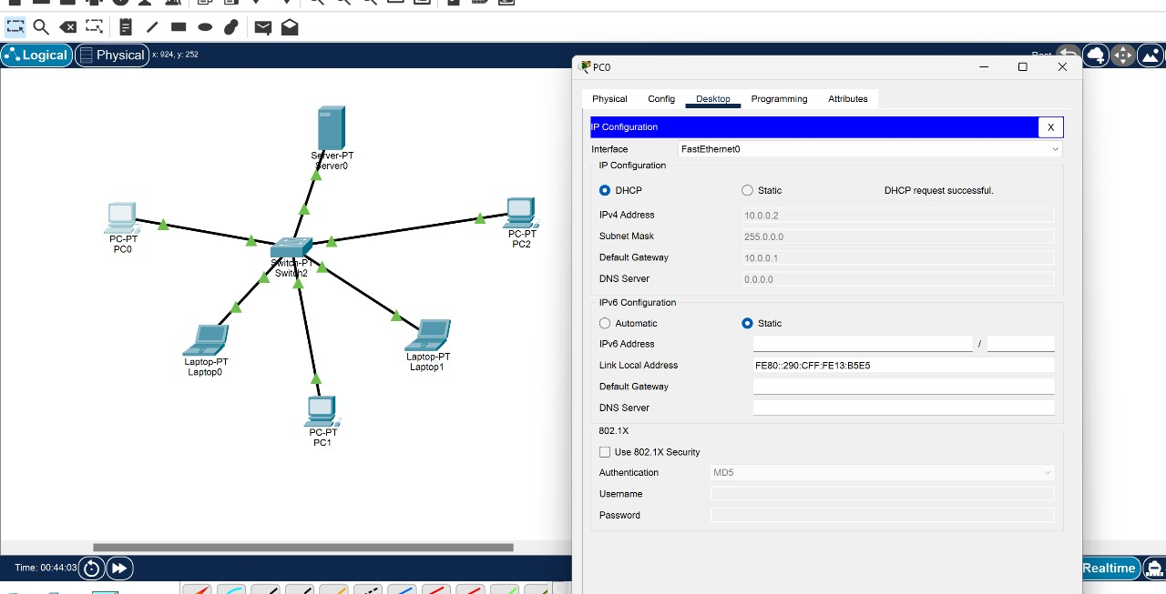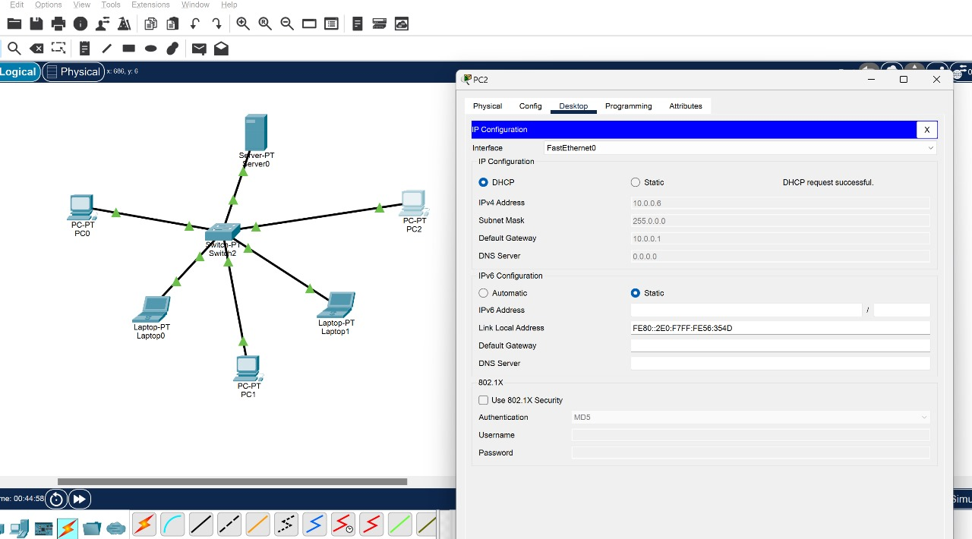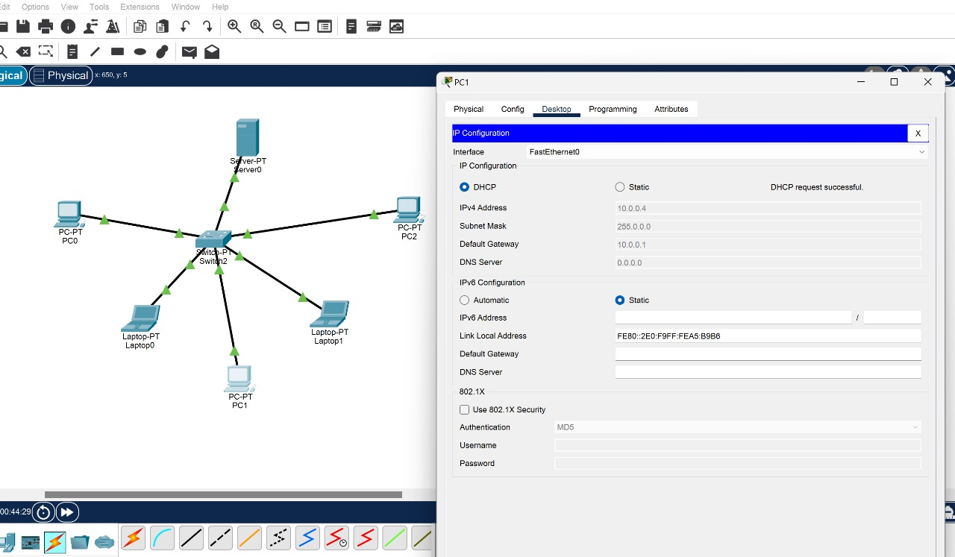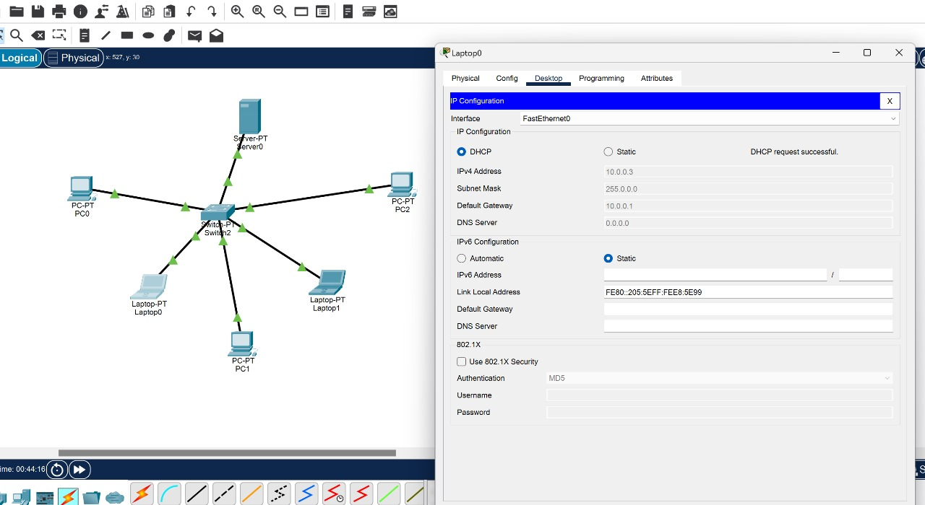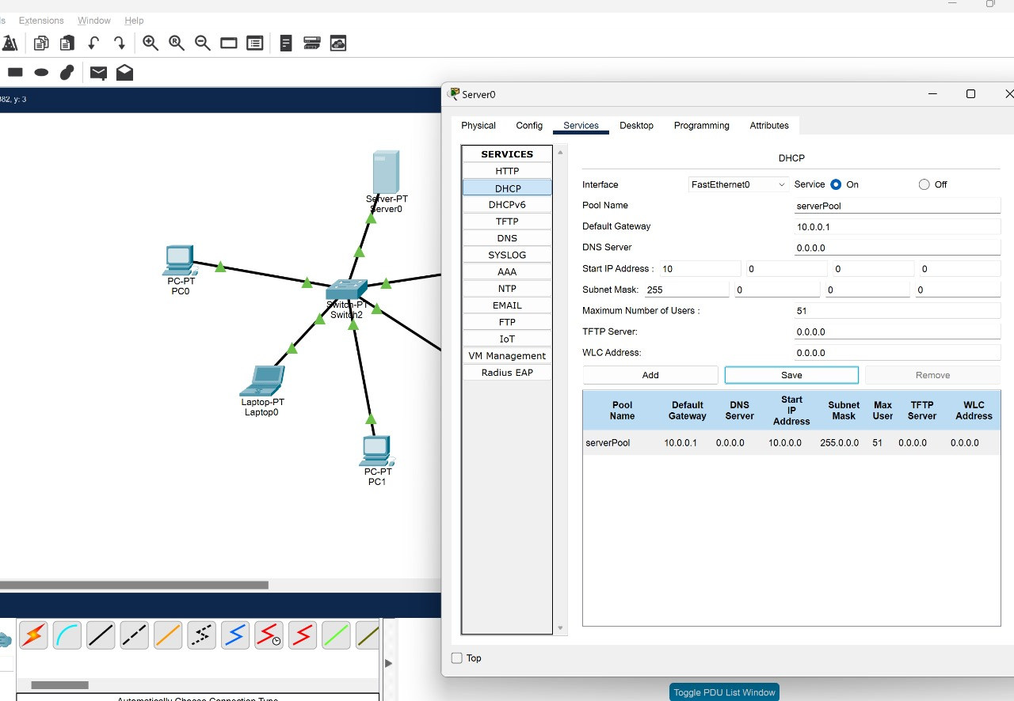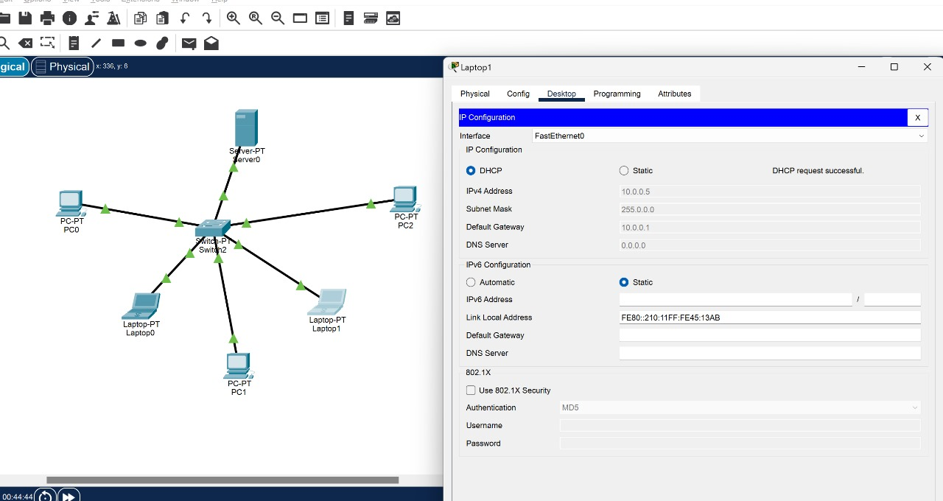

**4. Observations**

* The **DHCP server** correctly assigns IP addresses dynamically to the PCs and laptops.
* The **IP addresses assigned** fall within the range 10.0.0.10 - 10.0.0.50.
* Devices can **communicate** with each other and the server.
* Using **DHCP reduces manual configuration efforts**, making network management easier.